Lab Report Walkthrough – 1 (2.9.2)

Title: Configuration and Verification of Basic Switch Settings

Objective
The objective of this lab was to:
- Build a small switched network topology using Cisco Packet Tracer
- Configure IP addressing on end devices
- Perform basic switch configuration (hostname, passwords, VLAN interface, banner)
- Verify connectivity between devices
- Save the configuration to NVRAM

Part 1: Set Up the Network Topology
In Part 1, we built the physical network according to the given topology.
Step 1: Place Devices
- Placed two Cisco 2960 switches: S1 and S2
- Placed two PCs: PC-A and PC-B
Step 2: Connect the Devices
- Connected S1 Fa0/1 to S2 Fa0/1 using a Copper Crossover cable
- Connected PC-A to S1 Fa0/6 using a Copper Straight-Through cable
- Connected PC-B to S2 Fa0/18 using a Copper Straight-Through cable
After connecting:
All devices were powered on
- Waited for the link lights to turn green
- Verified physical connections were correct
This completed the physical topology setup.
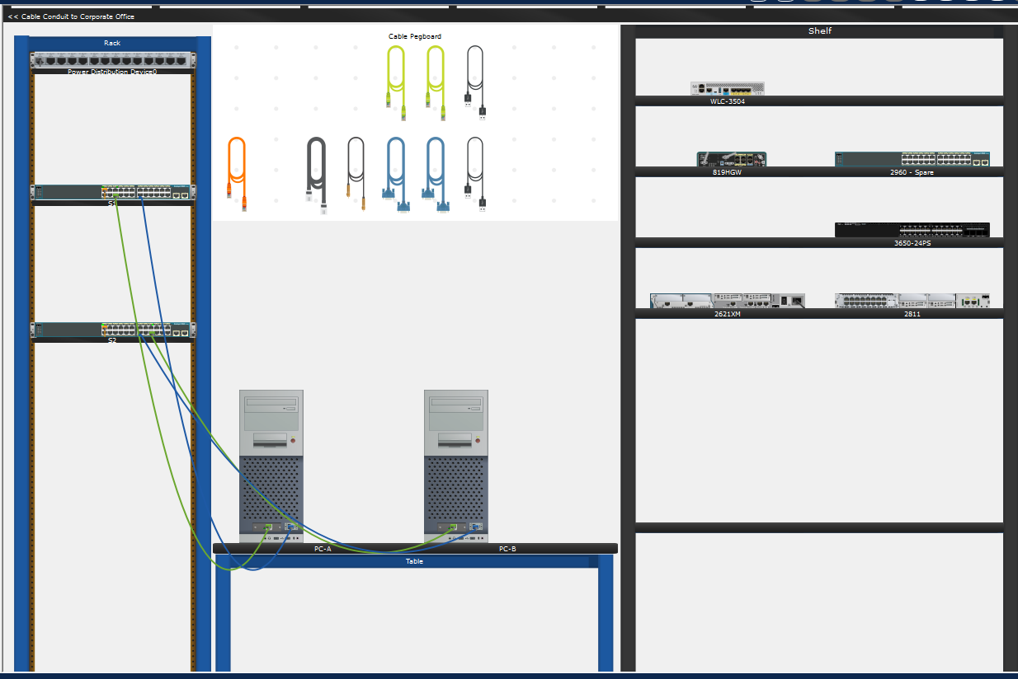

Part 2: Configure PC Hosts
In Part 2, we assigned IP addresses to both PCs.
Static IP addressing was configured as follows:
- PC-A Configuration:
- IP Address: 192.168.1.10
- Subnet Mask: 255.255.255.0
- Default Gateway: Left blank/Not Required
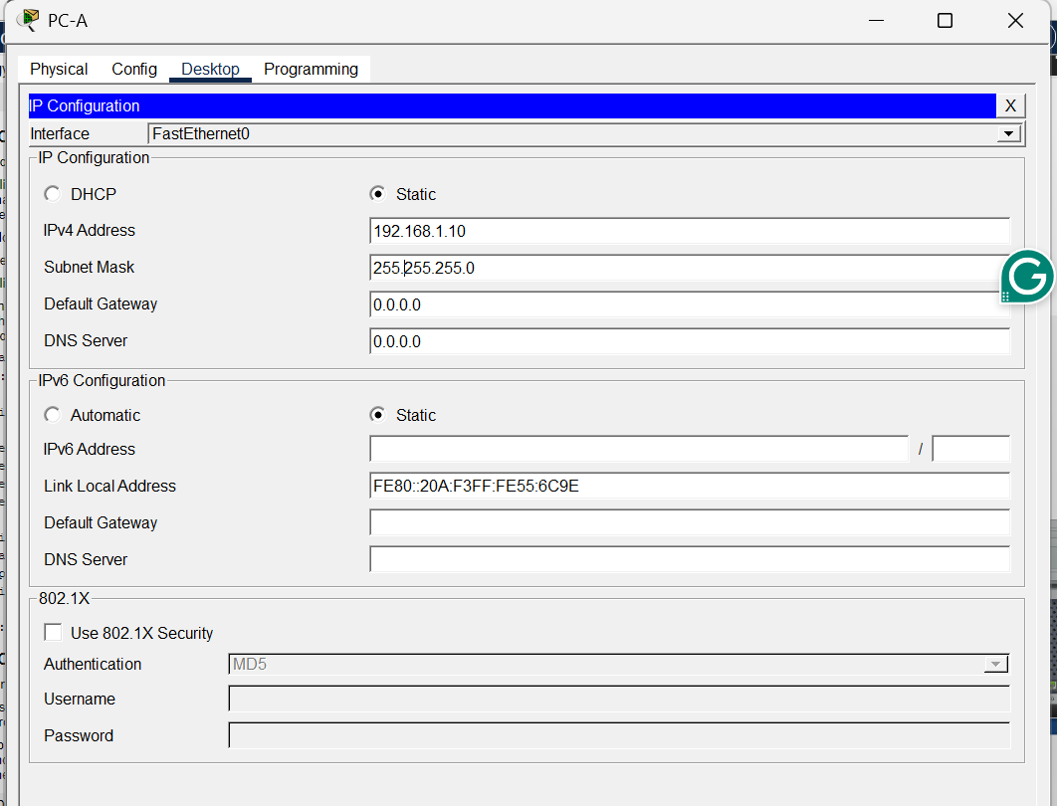
- PC-B Configuration:
- IP Address: 192.168.1.11
- Subnet Mask: 255.255.255.0
- Default Gateway: Left blank/Not Required
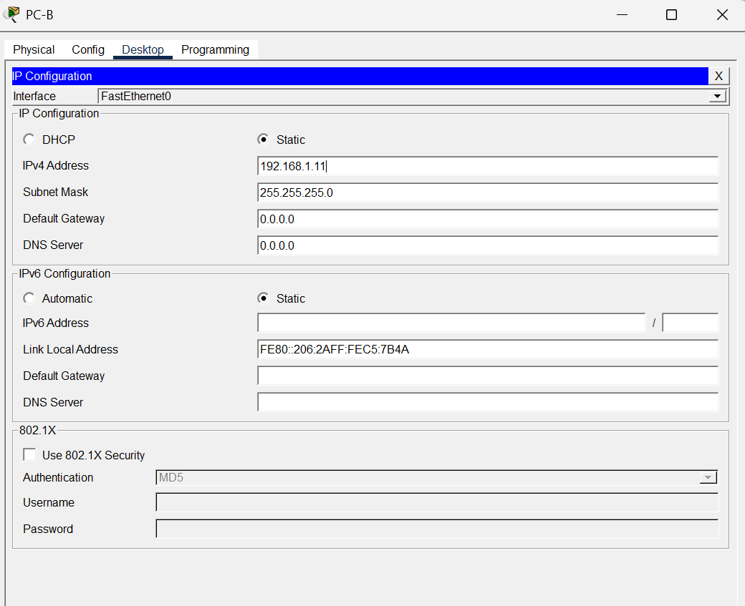
- Connectivity Verification (PC to PC):
From PC-A Command Prompt:
Code: ping 192.168.1.11
Result:
- 4 packets sent
- 4 packets received
- 0% loss
This confirmed that PC-A and PC-B were successfully communicating.
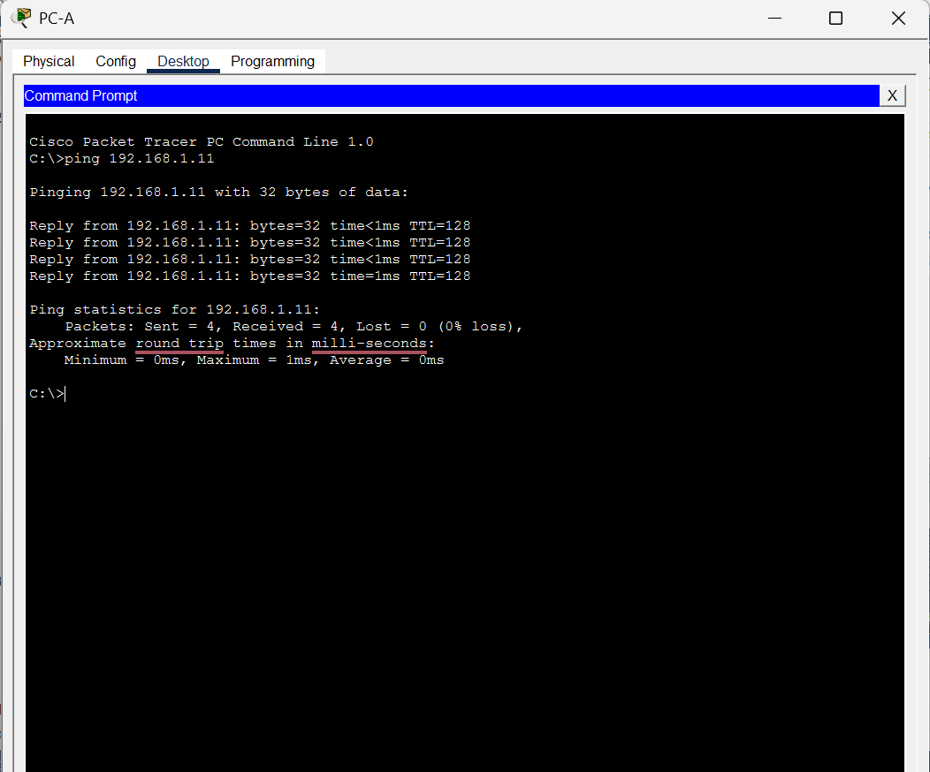
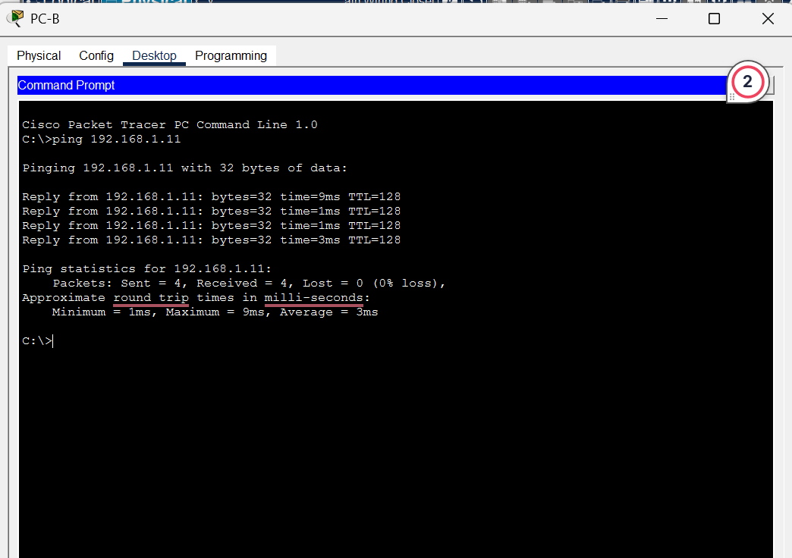

Part 3: Configure and Verify Basic Switch Settings
In Part 3, we configured both switches using console access.
Step 1: Access Switch via Console
- Connected console cable between PC-A and S1
- Opened Terminal from PC-A
- Entered privileged mode using: enable (en)

Step 2: Configuration of S1
Entered global configuration mode: configure terminal (conf t)
The following configurations were applied:
- Hostname set to SnehaS1
- Enable the secret password configured as: enable secret class
- Console password configured as:
line console 0
password cisco
login
exit
- VLAN 1 interface assigned IP address:
interface vlan 1
Ip address 192.168.1.2 255.255.255.0
no shutdown
exit
- MOTD banner configured to restrict unauthorized access:
banner motd # Unauthorized access is prohibited #
- Save Configuration
end
copy running-config startup-config

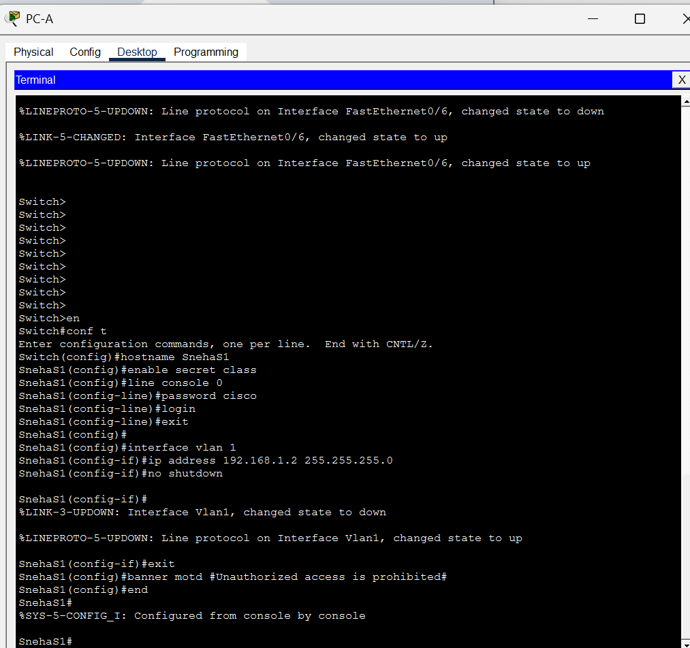
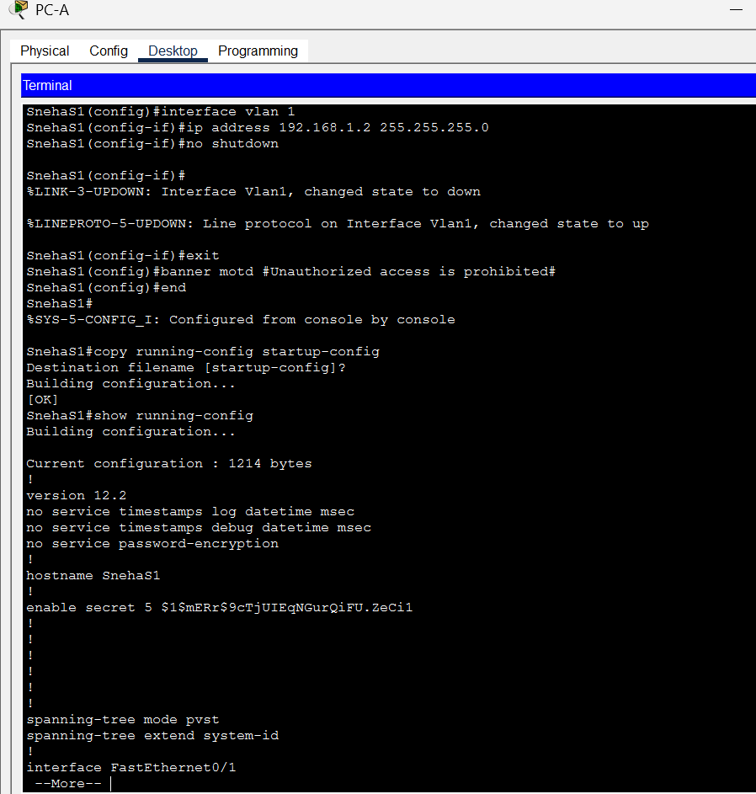

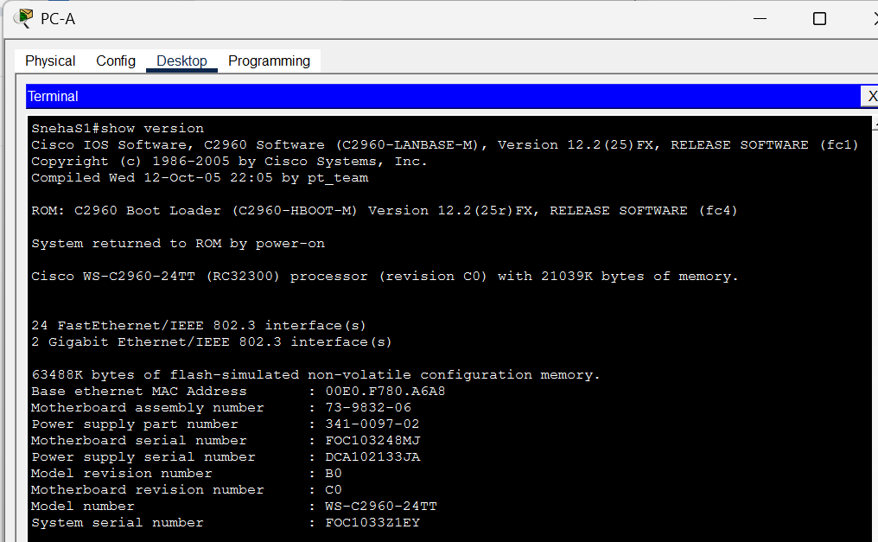
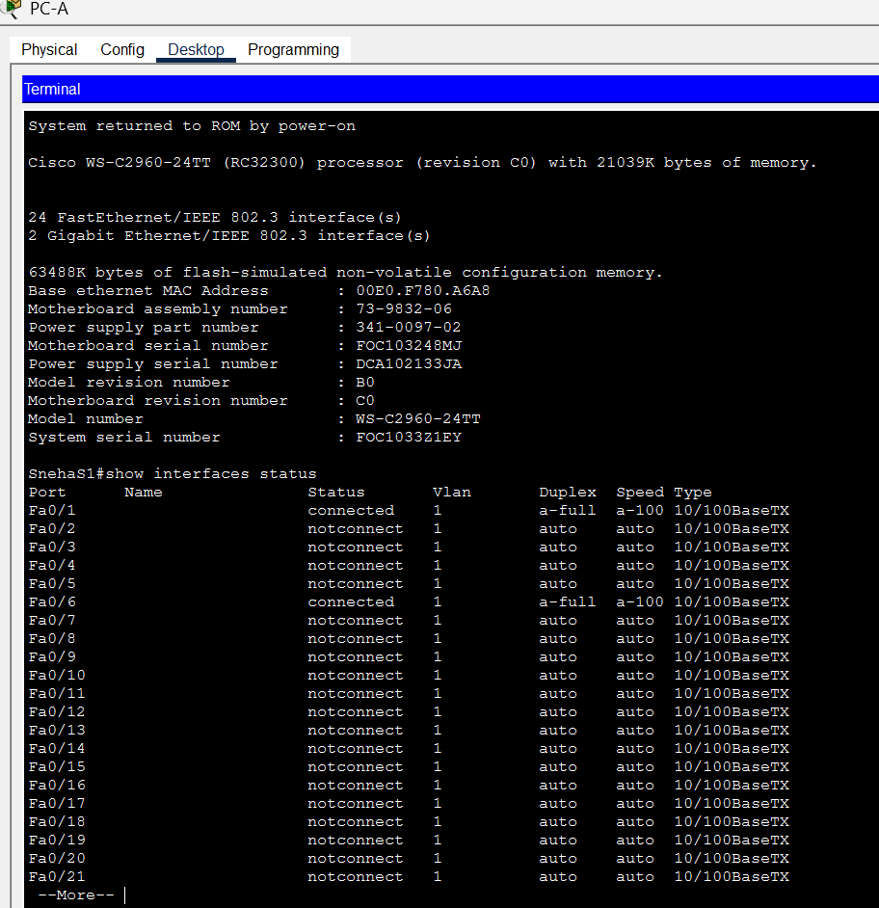
Step 3: Configure S2
The same steps were repeated for S2 with the following changes:
- Hostname set to S2
- VLAN 1 IP address configured as:
192.168.1.3 255.255.255.0

Configuration was saved to NVRAM.
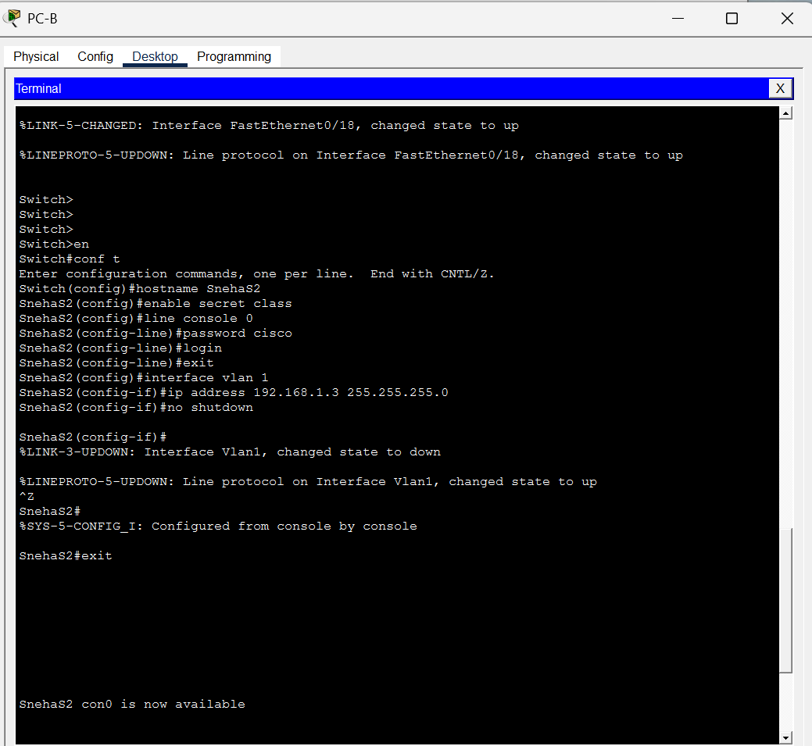
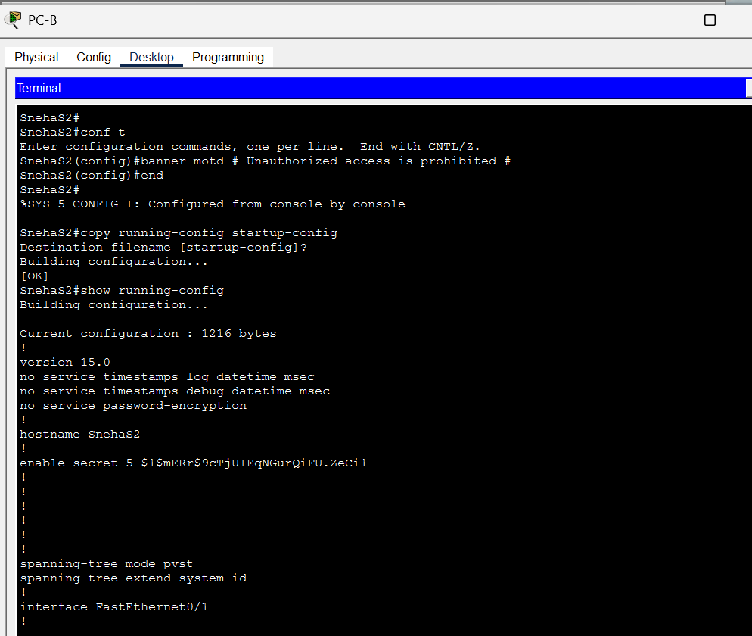

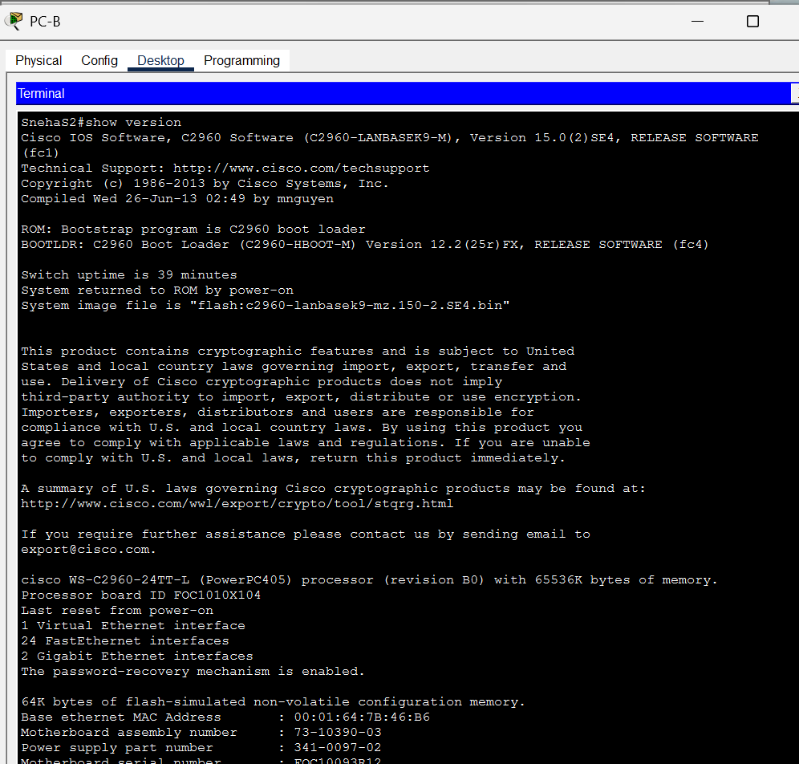
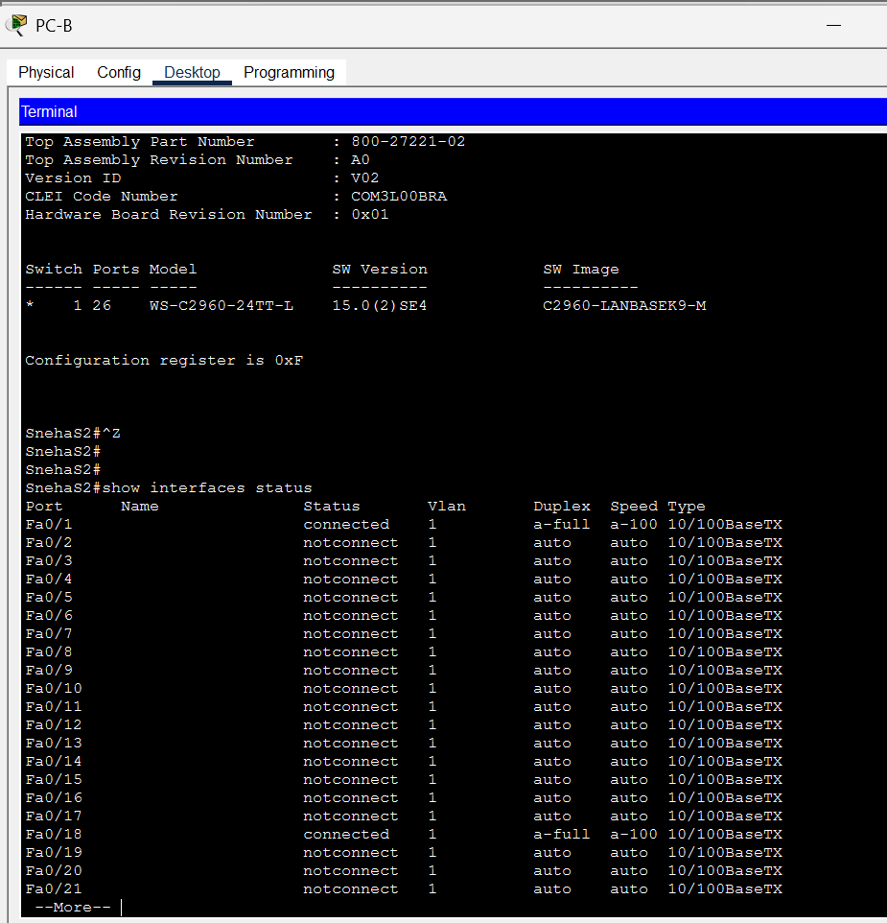

Final Testing
- From PC-A:
ping 192.168.1.2
ping 192.168.1.3
Result:
- First ping request timed out (due to ARP resolution)
- Remaining pings successful
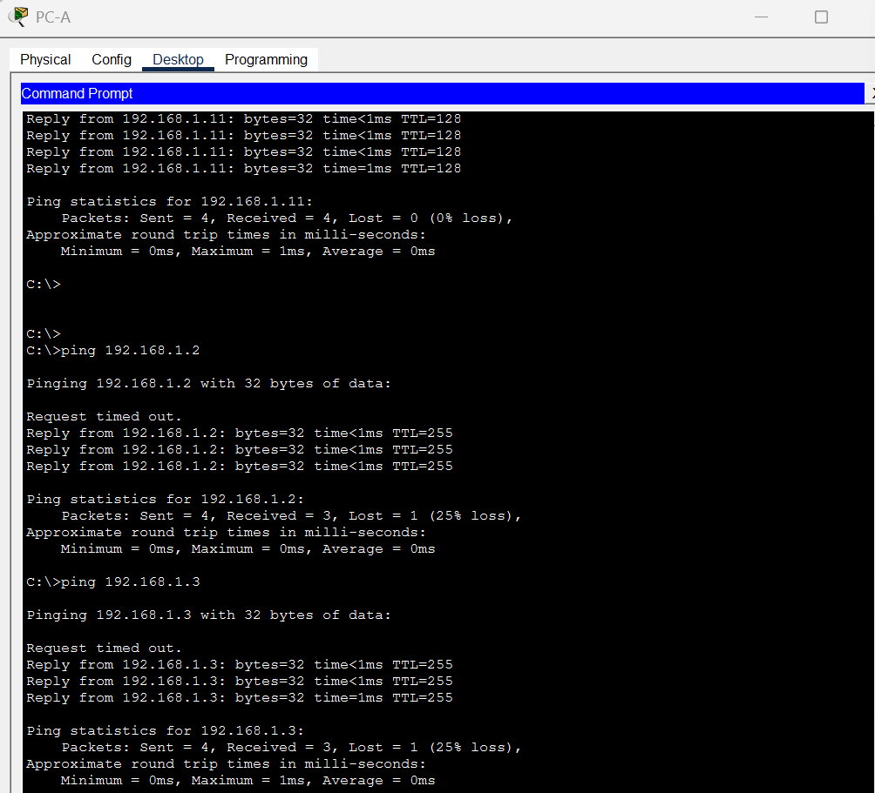
- From Switch:
From switch CLI:
ping 192.168.1.10
ping 192.168.1.11
Result:
- Successful replies received
- 100% success rate
- Interface Verification
The following command was used:
show Ip interface brief
Results:
- Fast Ethernet ports connected to devices showed up/up
- Unused ports showed down/down
- VLAN 1 interface showed up/up
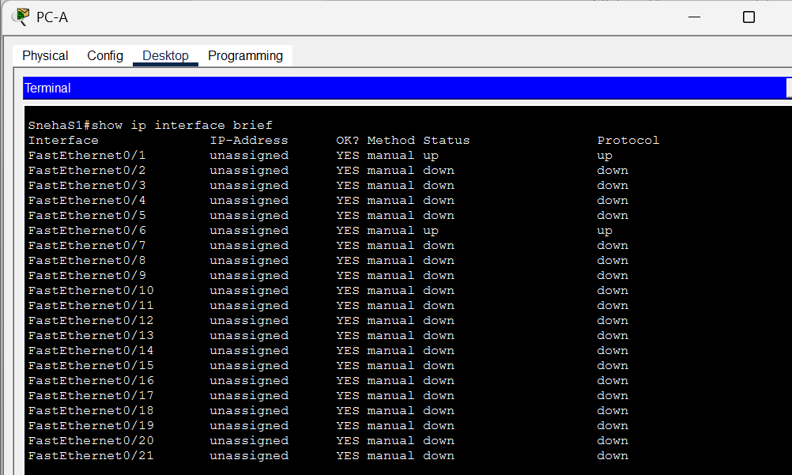
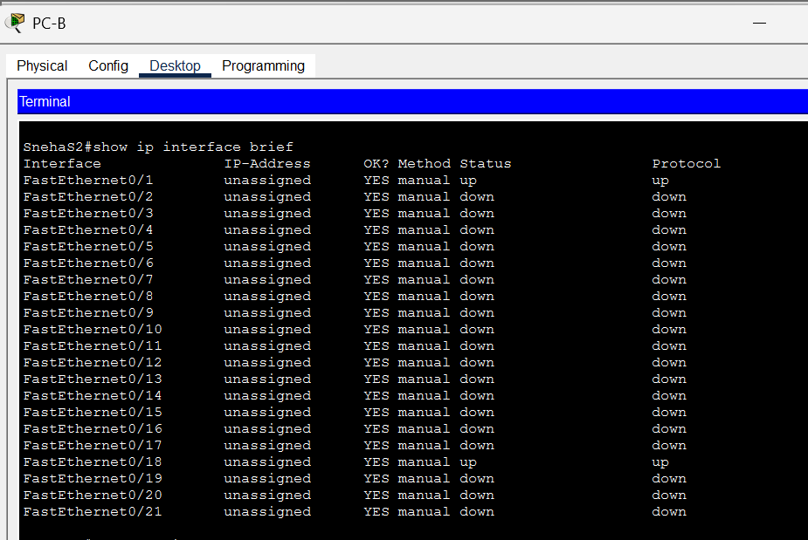

Conclusion
The lab objectives were successfully achieved. The network topology was correctly implemented, and all devices were properly configured with static IP addresses and basic switch settings.
Connectivity between PCs and switches was verified through successful ping tests. The configuration was saved to NVRAM to ensure persistence after reboot.
This lab provided a practical understanding of:
- Physical topology was correctly configured.
- IP addresses were properly assigned.
- Switch basic settings were successfully configured.
- Connectivity between PCs and switches was verified.
- All pings were successful.
- Configuration was saved to NVRAM.
The lab was completed.

Reflections Questions: -

Why are some FastEthernet ports on the switches up while others are down?
- Some FastEthernet ports on the switches are up while others are down because they are: -
- Connected to active devices (PC or another switch)
- Using proper cables
- Devices are powered ON
- Ports are down because:
- No cable is connected
- The device on the other side is OFF
- The port is administratively shut down
- The wrong cable is used
A switch port becomes up only when there is an active connection.
- What could prevent a ping from being sent between the PCs?
- A ping could prevent being sent between the PCs because of:
- Wrong IP address
- Different subnet masks
- Same IP address on both PCs (IP conflict)
- Cable not connected properly
- The switch port is down
- VLAN misconfiguration
- Firewall blocking ICMP (in real networks)
If devices are not correctly configured or not physically connected, ping will not work.

